**Hotel Management**

**Scenario**

You have been hired by the Artemis Hotel to create a hotel management system. The system will be used by the hotel for managing customers bookings and their details.

The program system must be capable of providing the following information:

Hotel Booking, Provide you with Hotel Rooms Info, Room Service, Billing and Record-Keeping.

**Methods**

* Analyse the detailed requirements using suitable methods, i.e. analysis by decomposition of requirements (breaking down the tasks into manageable parts)
* Elements and functions table
* algorithms / pseudocode or flow diagram
* Show the iterative development of the individual solutions with suitable testing throughout the process.
* Test the final product with an appropriate test table and evaluate your solution against the detailed requirements you identified in the analysis.

**System Requirements**

* Main Menu options
* Personal details: including type of room and service booked.
* Hotel room details: Type of room, number of persons, number of beds, what is included in the room i.e. on-suite, couch, TV etc.
* Bookings
* Billing and payments
* Record keeping guest records, guests and allocated rooms, vacancy of rooms, room services
* Database CSV document for customer / guests’ details
* Test table to show that the system works.

**s**

**Example of Functions Required:**

Home()- Function to display the project’s main screen i.e. the home page of the project or you can say the main menu for selecting the desired operation to perform.

Date(str)- Function to validate date entered by the user/customer.

Booking()- Function for booking room in hotel by entering user/customer details.

Room_Info()- Function to provide users/customers with hotel rooms information(i.e. about room amenities).

Restaurant()- Function for room service which provides user/customer with the restaurant’s menu card to order food at the room.

Payment()- Function for payment of hotel room and restaurant bill generation at the time of check-out.

Record()- Function for keeping records of customers stayed in the hotel.

Client Requirement 

|  |  |  |
| --- | --- | --- |
| **Requirement ID** | **Description** | **Mandatory [M] or desirable [D]** |
| . 1RoomType | Type of room, suite, etc | M |
| 1.Persons | How many people | D |
| 3.GuestsNames4 | Guests’ forename | M |
| 1.Numberofbed | Number of beds | M |
| 5.Roomadditions | Any add-ons, such as on-suite, couch or a TV | D |
| 6RoomAvailability | Is room available | M |

Task Table 

|  |  |
| --- | --- |
| **Requirement ID** | **Description** |
| 1 | Store login details |
| 2 | Create login details |
| 3 | Create user access |
| 4 | Check user details |
| 5 | Check rooms |
| 6 | Create booking |
|  |  |

Flow Diagram

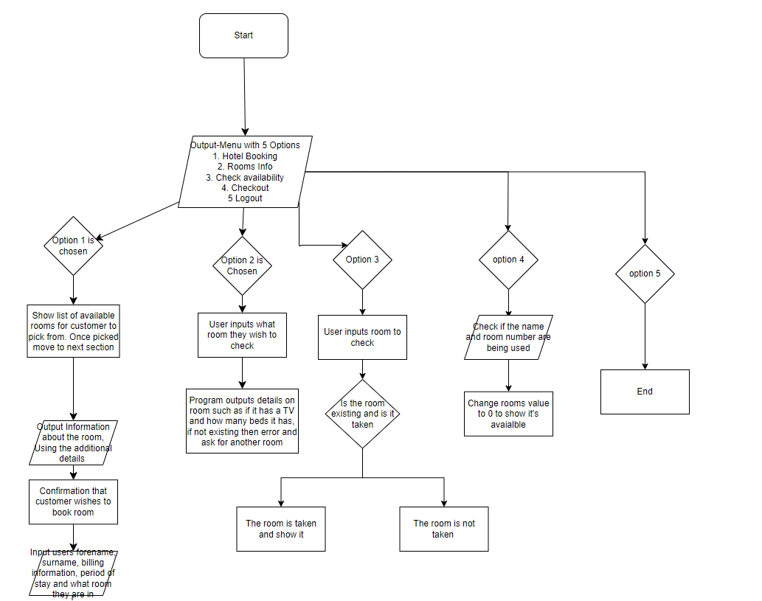

Pseudocode

Variable Table

|  |  |  |  |
| --- | --- | --- | --- |
| **Variable Name** | **Description** | **Data Validation** | **Data Type** |
| Customer_name | Name of customer booking |  | string |
| Room_number | Room number |  | string |
| customers | Info on customer |  | dict |
| rooms | All rooms |  | dict |
| Hotel_system | Hotelbookingsystem as a whole |  | string |
| choice | Workers input |  | string |
|  |  |  |  |

Method Table

|  |  |  |  |
| --- | --- | --- | --- |
| **Method Name** | **Input** | **Process** | **Output** |
|  |  |  |  |
|  |  |  |  |
|  |  |  |  |
|  |  |  |  |
|  |  |  |  |
|  |  |  |  |
|  |  |  |  |

Testing Plan

1. Use of Testing to Identify Defects (Explain your test table, the columns you used and what you where testing)
2. How you will be documenting the testing process (e.g Show screenshots of your testing and explain each step)
3. Explain any changes you have made to the Solution during testing. (Show any solutions that you came up with after your testing)

TestingTable

|  |  |  |  |  |  |  |
| --- | --- | --- | --- | --- | --- | --- |
| Test Type | Test Data | Reason | Expected Outcome | Actual Outcome | Pass or Fail? | Actions Required? |
| Is it possible to add new rooms | Self.rooms | For the purpose of working on the program | Yes | Yes | Pass |  |
| Does the menu work | Show_menu | For purpose of the program being usable | Yes | Yes | Pass |  |
| Does the inputs work | Customer_name room_number | For the purpose of users being able to input data | Yes | No | Fail | Fixed by using inputs of the correct type such as ints and strings |
| Does program print out the correct data on rooms | View_room_details | For the reason of being able to see view details | Yes | no | Fail | Mistyped variables |
| Able to check if a room is available | Check_availability | To see if function works | Yes | Yes | Pass |  |
|  |  |  |  |  |  |  |
|  |  |  |  |  |  |  |
|  |  |  |  |  |  |  |
|  |  |  |  |  |  |  |

Evaluation

**Comparison to designs​**

* Provide a well-developed line of reasoning which is clear and logically structured. The information presented is relevant and substantiated.​
* Discuss the maintainability of the solution. ​
* Discuss potential further developments of the solution. ​
* Discuss any changes and why they are different from the original designs.

My Evaluation